Assignment
Fundamental Theory
(LAB: 2)
NAME: Majid Ali
CMS ID: 053-25-0017
PROGRAM: Software engineering (Section: A)

Question 1:
Write a program that takes 5 values from the user:
one value of String (name),
one value of int (age),
one value of double (salary),
one value of boolean (isMarried),
one value of char (grade).
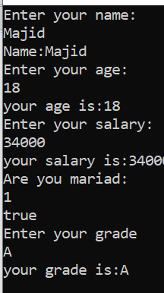
Print each value on a separate line.
#include<iostream>
using namespace std;
int main(){
string name;
int age;
double salary;
bool ismariad;
char grade;
cout<<"Enter your name:"<<endl;
cin>>name;
cout<<"Name:"<<name<<endl;
cout<<"Enter your age:"<<endl;
cin>>age;
cout<<"your age is:"<<age<<endl;
cout<<"Enter your salary:"<<endl;
cin>>salary;
cout<<"your salary is:"<<salary<<endl;
cout<<"Are you mariad:"<<endl;
cin>>ismariad;
cout<<boolalpha<<ismariad<<endl;
cout<<"Enter your grade"<<endl;
cin>>grade;
cout<<"your grade is:"<<grade<<endl;
return 0;

}
Question 2:
Write a program that takes Marks Obtained (float) and Total Marks (int) from the user. Calculate and print Percentage using the following formula:
𝐏𝐞𝐫𝐜𝐞𝐧𝐭𝐚𝐠𝐞 = 𝐌𝐚𝐫𝐤𝐬𝐎𝐛𝐭𝐚𝐢𝐧𝐞𝐝/ 𝐓𝐨𝐭𝐚𝐥𝐌𝐚𝐫𝐤𝐬 ⨉100
#include<iostream>
using namespace std;
int main(){
float marksobtain;
int Totalmarks;
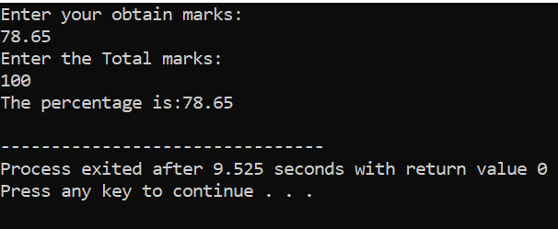
cout<<"Enter your marks"<<endl;
cin>>marksobtain;
cout<<"Enter the marks"<<endl;
cin>>Totalmarks;
float percentage=marksobtain/Totalmarks*100;
cout<<"The percentage is:"<<percentage<<endl;
return 0;
}
Question 3:
#include<iostream>
using namespace std;
int main(){
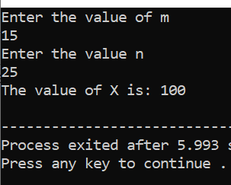
int m;
int n;
cout<<"Enter the value of m"<<endl;
cin>>m;
cout<<"Enter the value n"<<endl;
cin>>n;
int x=(m*m)+(n*n)-2*m*n;
cout<<"The value of X is"<<x<<endl;
return 0;
}

Question 4:
Write a program that asks the user to type character then the program will generate its ASCII value. The sample output is shown below:
#include<iostream>
using namespace std;
int main(){
char ch;
cout<<"Enter the character: ";
cin>>ch;
cout<<"The ASCII value is: "<<(int)ch<<endl;
return 0;
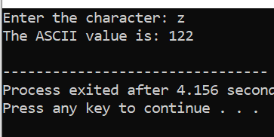
}

Question 5:
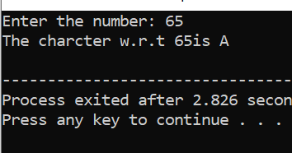
Write a program that takes a Number (integer) input from the user and then it prints the Character associated with that ASCII. Let’s suppose if User input is 65 then A should be printed on screen.
#include<iostream>
using namespace std;
int main(){
int num1;
cout<<"Enter the number: ";
cin>>num1;
cout<<"The charcter w.r.t "<<num1<<"is "<<(char)num1<<endl;
return 0;
}
Question 6:
Write a program that asks the user to type lowercase (small) alphabet character then the program will generate its uppercase (capital) alphabet character. The sample output is shown below:
#include <iostream>
using namespace std;
int main(){
char a;
cout<<"enter the Lowercase alphabet character: ";
cin>>a;
char ch=a-32;
cout<<"The Uppercase of alphabet chracter is: "<<ch<<endl;
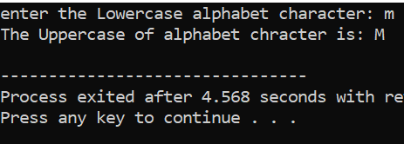
return 0;
}

Question 7:
Write a program that asks the user to type uppercase (capital) alphabet character then the program will generate its lowercase (small) alphabet character. The sample output is shown below:
include <iostream>
using namespace std;
int main(){
char a;
cout<<"enter the Upercase alphabet character: ";
cin>>a;
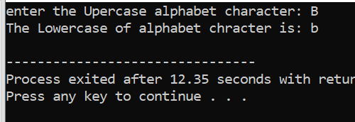
char ch=a+32;
cout<<"The Lowercase of alphabet chracter is: "<<ch<<endl;
return 0;
}

